**Setting Work Order Master Data Service**

1. Clone the Repo from : <https://github.com/handaanmol/master-data-service>

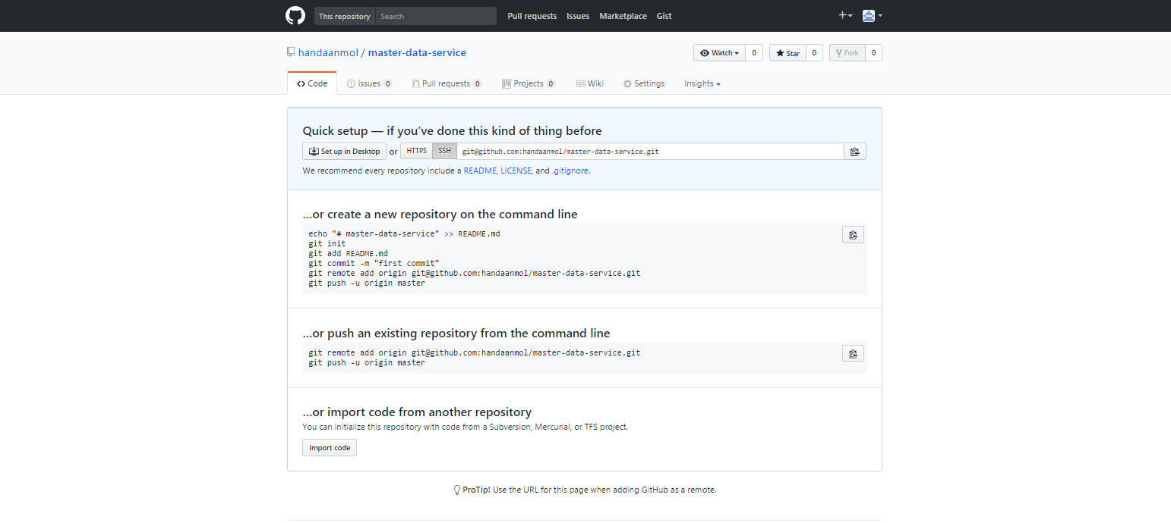

1. Follow the Readme file on Github to run the application on your local machine

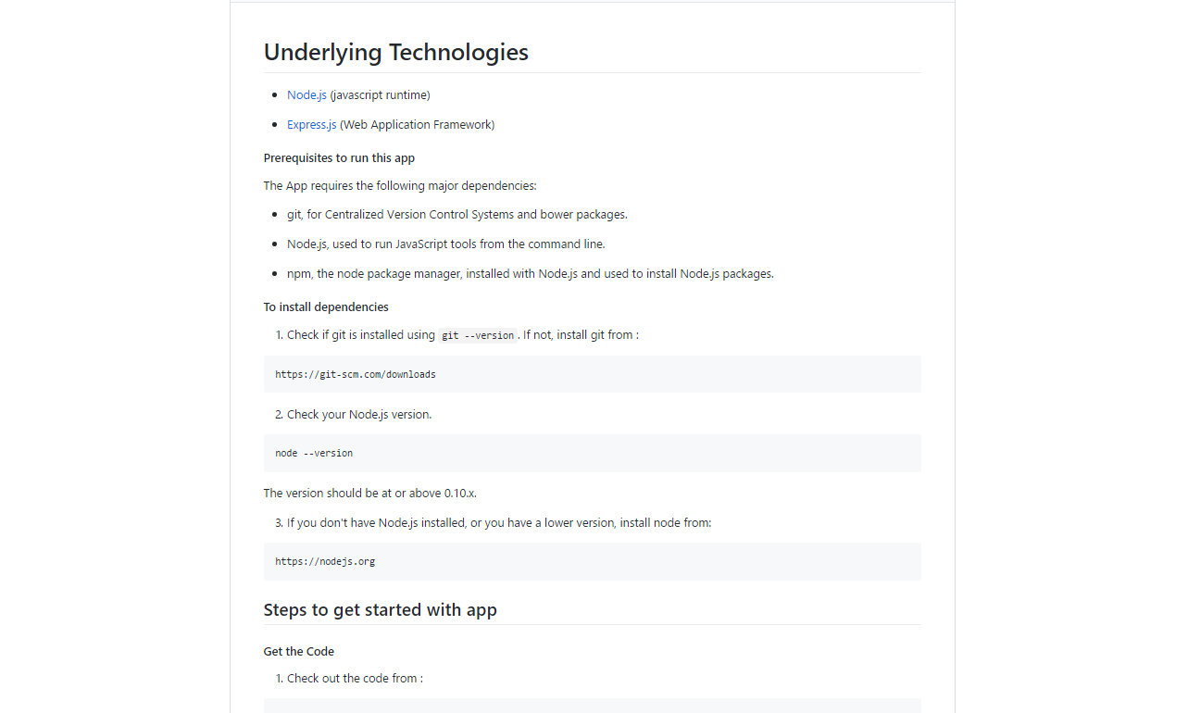

1. Login to Azure

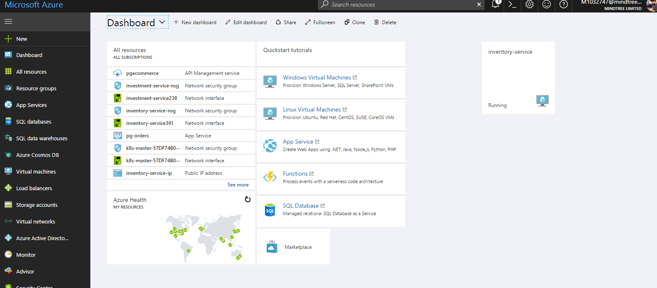

1. Go to left nav bar on portal and click on new and search for API APP , once found click on it.

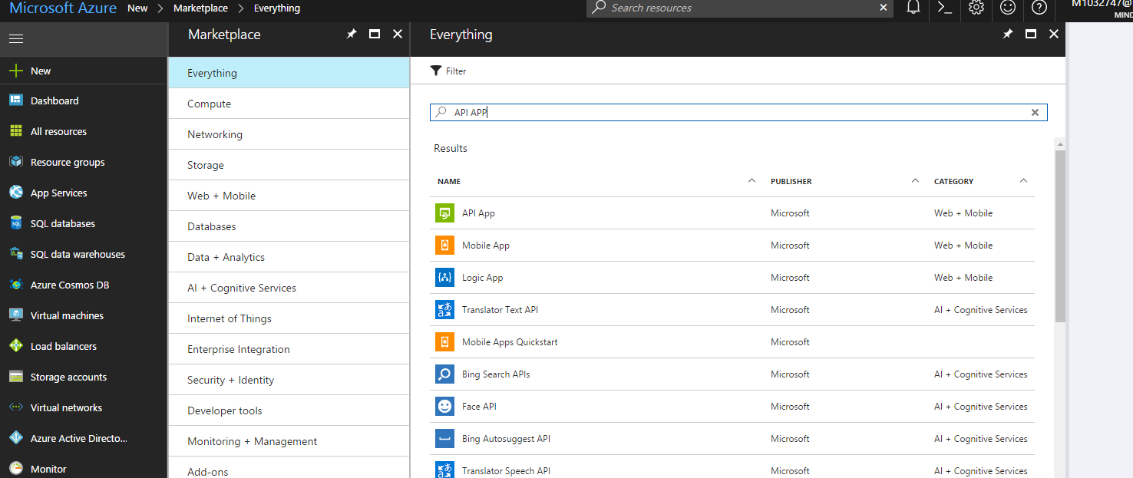

1. Create API APP

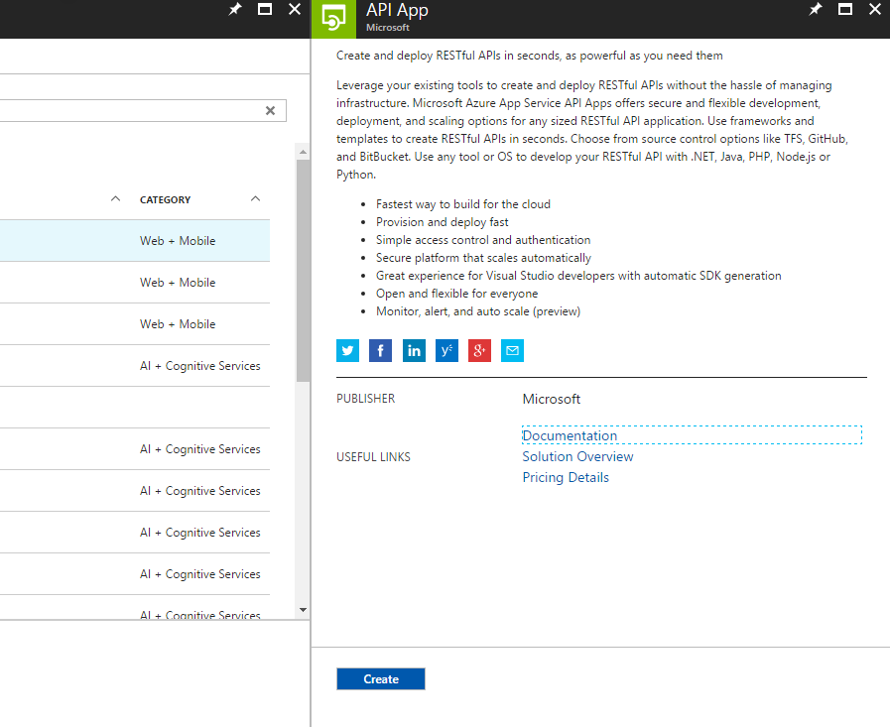

Add the following details while creating the API APP

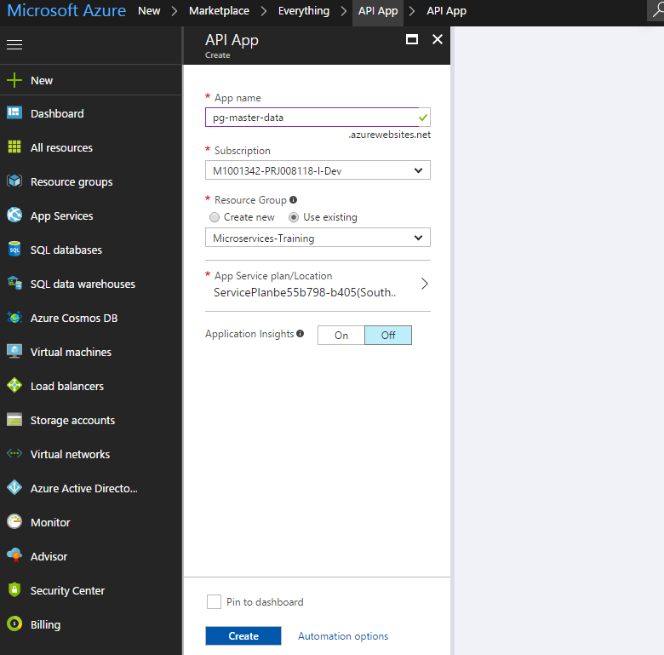

1. Go to App Services from left nav bar and click on pg-master-data

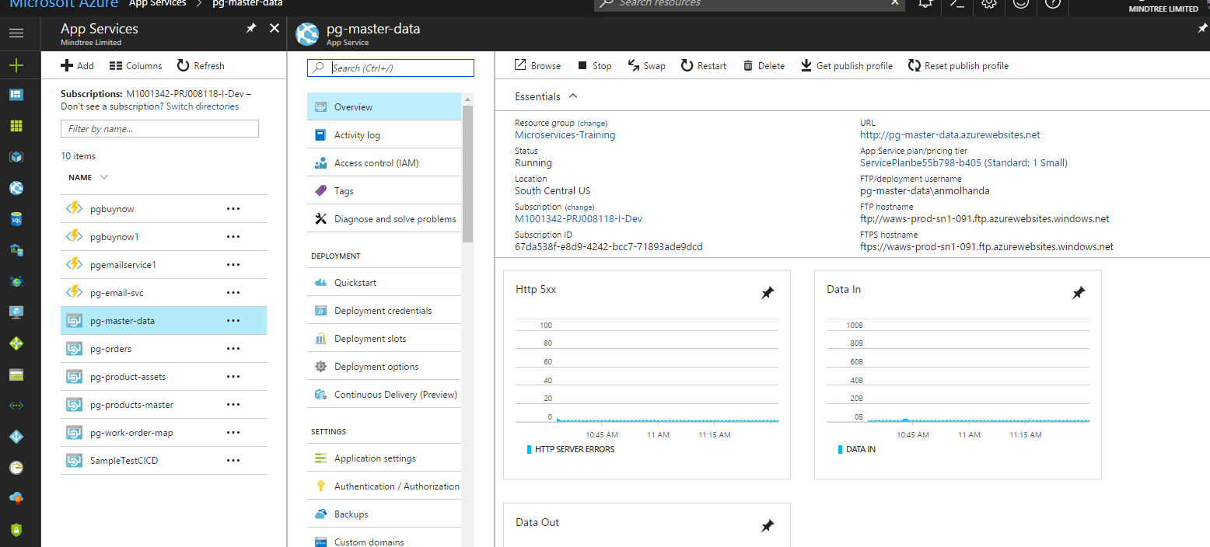

1. Click on deployment options.

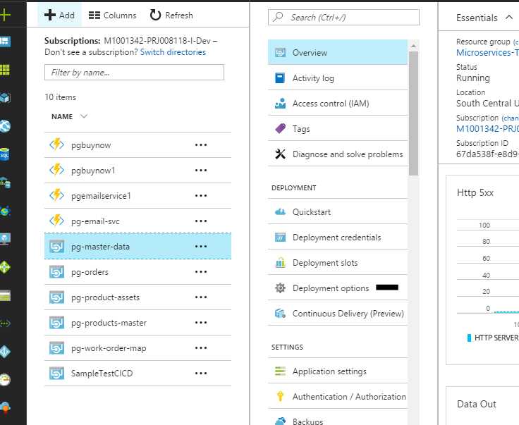

1. Add the github repository which we created above as shown below

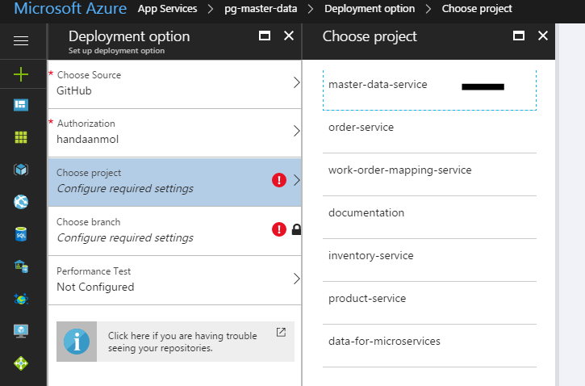  
  
Press ok once done

1. Wait for deployment to get completed

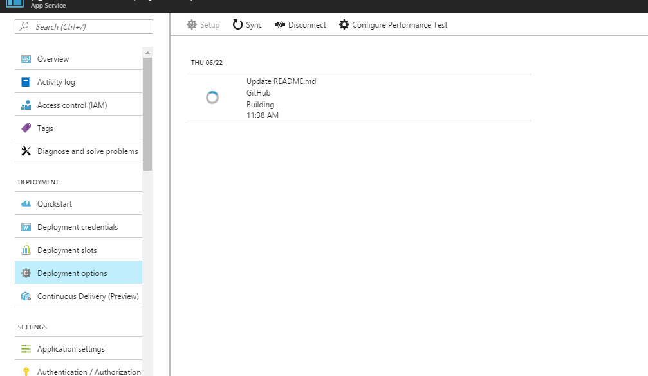

1. Search for API Management in search bar and open it

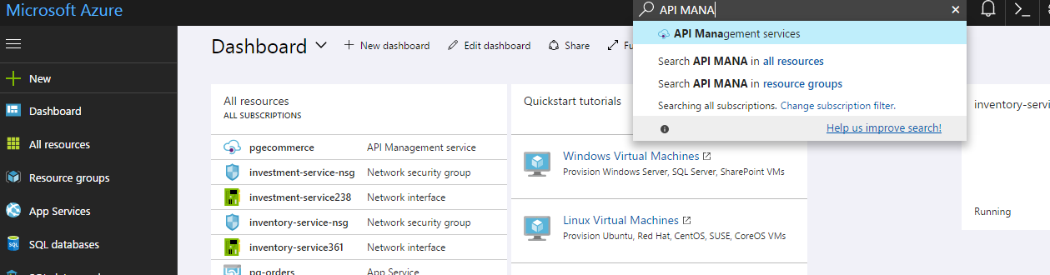

1. Select pgecommerce and select APIs preview

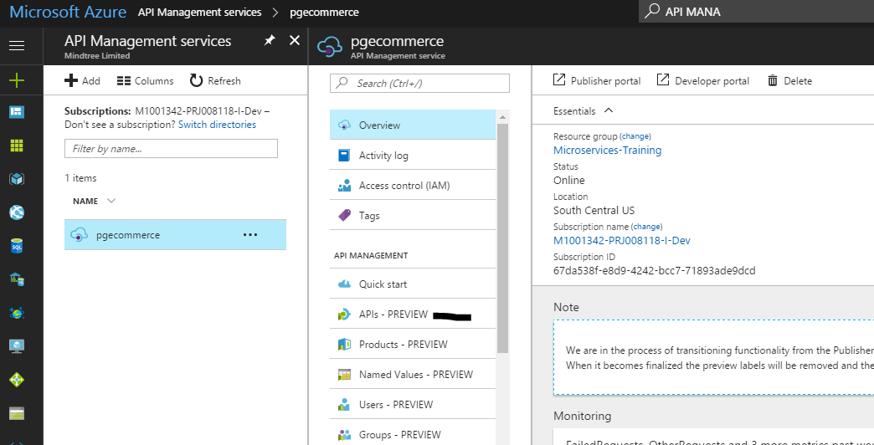

1. Select API APP

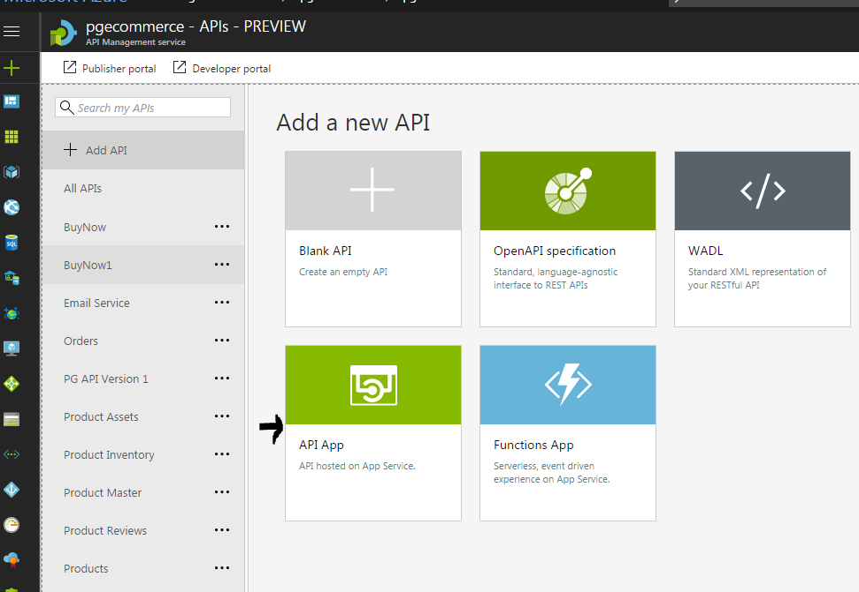

1. Fill the details by selecting the API APP which we created a while back

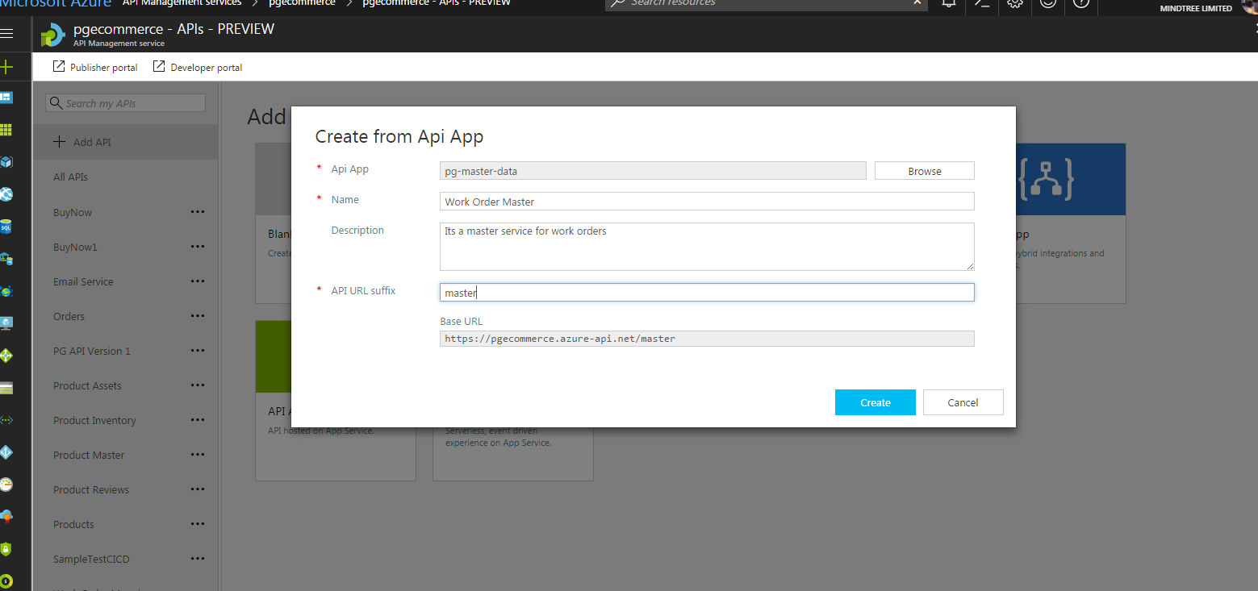

1. Once you create you can see your work order master as API as shown below.

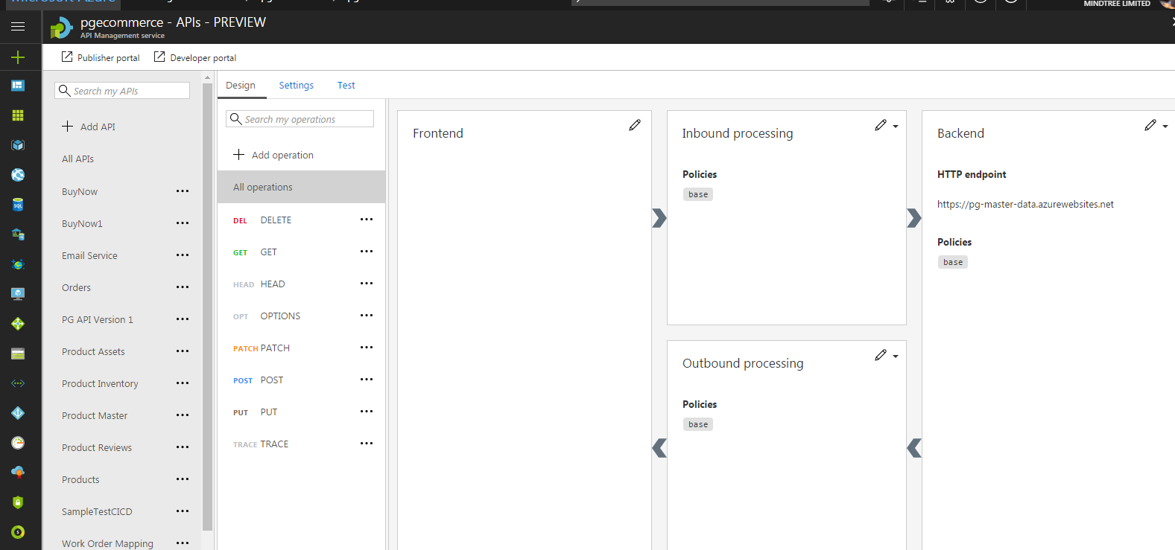

1. Add operations as per you requirements

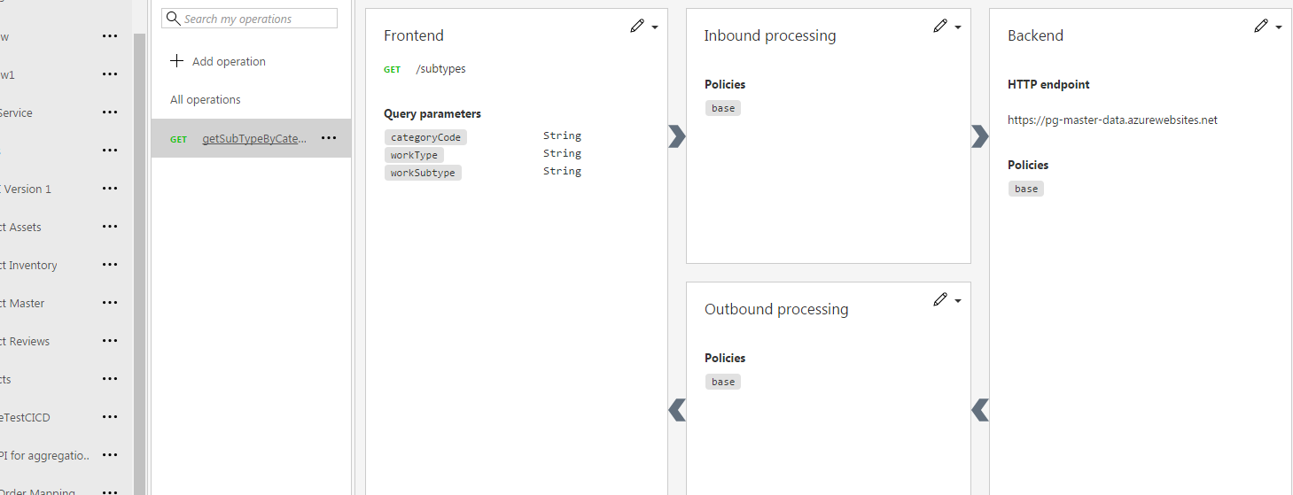

1. Go to API Management Services and Products Review and add your API in the free trial as shown below

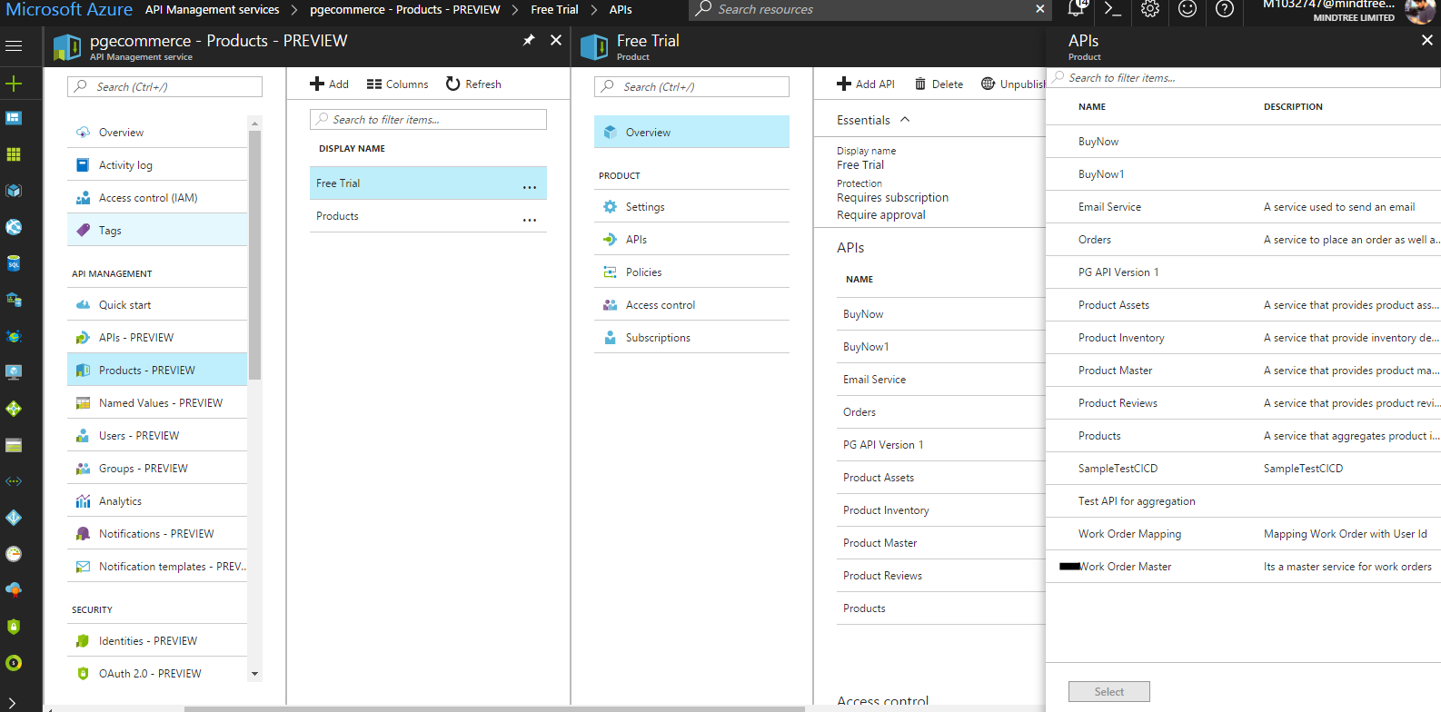

1. You can access the API at :

https://pgecommerce.azure-api.net/master/subtypes

the query params will be as follows:

**categoryCode**: **UDL1027076**

**workType : Carpets**

**workSubtype: Vacuum**

**Output** will be as given below:

{"data": { "workSubtypeCode": "UDL1027559" }, "status": { "statusCode": "", "message": "fetched the work subtype with category code : UDL1027076successfully.", "code": "200" } }